Set 20: Stock Analysis

- Yaswanth [192324179]

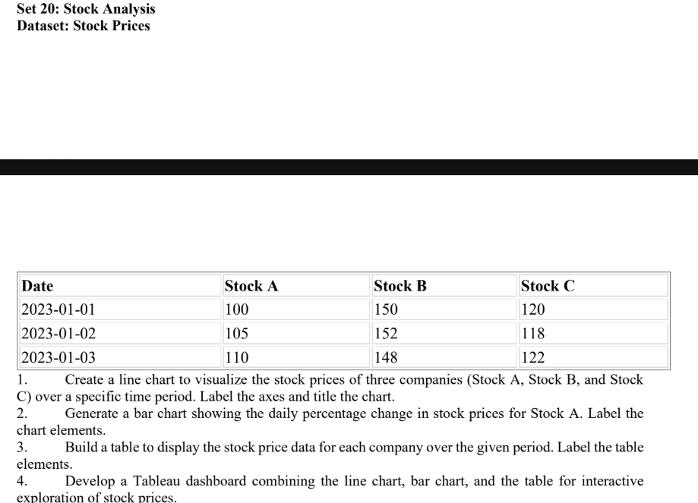
Question 1. Line chart for three stock prices
library(ggplot2)

stock <- data.frame(
Date = as.Date(c("2023-01-01", "2023-01-02", "2023-01-03")),
Stock_A = c(100, 105, 110),
Stock_B = c(150, 152, 148),
Stock_C = c(120, 118, 122)
)

stock_long <- data.frame(
Date = rep(stock$Date, 3),
Company = rep(c("Stock A", "Stock B", "Stock C"), each = 3),
Price = c(stock$Stock_A, stock$Stock_B, stock$Stock_C)
)

ggplot(stock_long, aes(x = Date, y = Price, color = Company)) +
geom_line(linewidth = 1) +
geom_point(size = 3) +
labs(
title = "Stock Prices Over Time",
x = "Date",
y = "Stock Price",
color = "Company"
) +
theme_minimal()

Output:
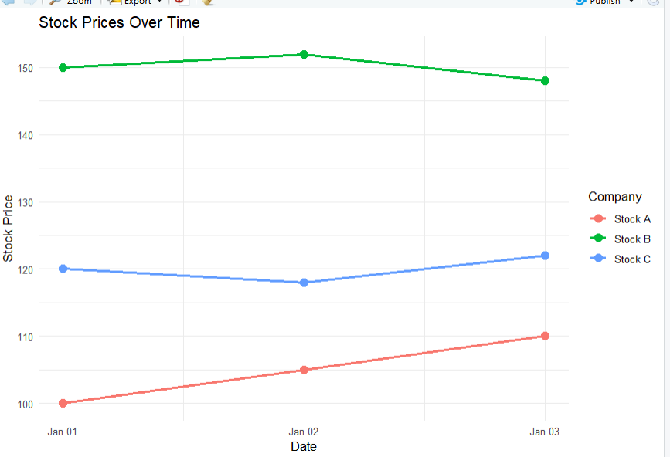
Result: The line chart compares the daily prices of all three stocks.
Question 2. Bar chart of daily percentage change in Stock A
library(ggplot2)

stock$Percentage_Change <- c(
NA,
diff(stock$Stock_A) / head(stock$Stock_A, -1) * 100
)

change_data <- stock[!is.na(stock$Percentage_Change), ]

ggplot(change_data, aes(x = Date, y = Percentage_Change)) +
geom_col(fill = "steelblue") +
geom_text(
aes(label = paste0(round(Percentage_Change, 2), "%")),
vjust = -0.5
) +
labs(
title = "Daily Percentage Change in Stock A",
x = "Date",
y = "Percentage Change (%)"
) +
theme_minimal()

Output:
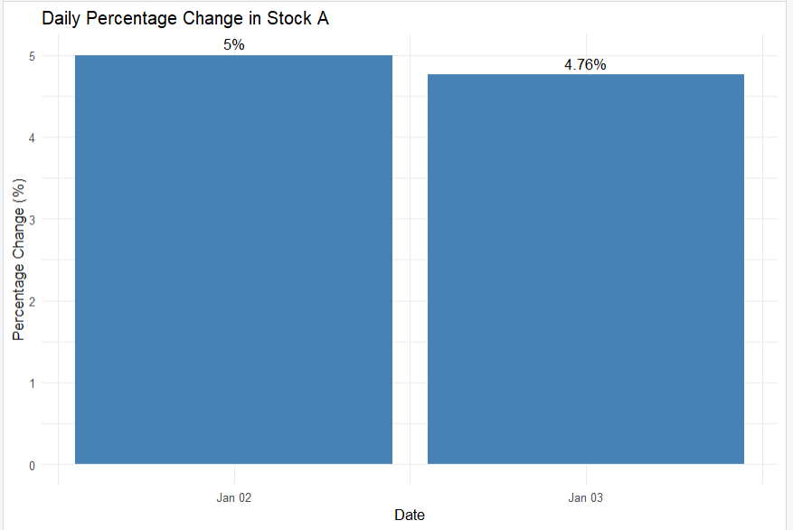
Result:
- January 2: 5.00%
- January 3: 4.76%
The first date has no percentage change because there is no previous day's price.
Question 3. Create a stock price table
stock_table <- data.frame(
Date = format(stock$Date, "%Y-%m-%d"),
Stock_A = stock$Stock_A,
Stock_B = stock$Stock_B,
Stock_C = stock$Stock_C,
Percentage_Change = ifelse(
is.na(stock$Percentage_Change),
"-",
paste0(round(stock$Percentage_Change, 2), "%")
)
)

print(stock_table)

Output:
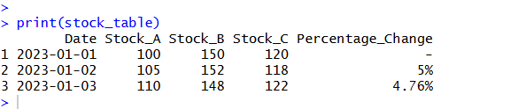
Question 4. Combine all outputs into one dashboard
Procedure:
- Enter the stock price data into Excel and save it as Stock_Prices.xlsx.
- Open Tableau and connect to the Excel file.
- Create the stock price line chart by placing Date on Columns, stock prices on Rows, and Measure Names on Color. Keep Stock A, Stock B, and Stock C.
- Create the percentage-change bar chart by calculating Stock A’s daily percentage change using the formula:
\[ \frac{\text{Current Price}-\text{Previous Price}} {\text{Previous Price}}\times100 \]
Place Date on Columns and Percentage Change on Rows. Select Bar and display the percentage labels.
5. Create the stock price table by displaying Date, Stock A, Stock B, and Stock C as text.
6. Click New Dashboard and name it Stock Analysis Dashboard.
7. Drag the line chart, percentage-change bar chart, and stock price table onto the dashboard.
8. Add a Date filter if required and enable Use as Filter on the line chart for interactive exploration.
9. Adjust the layout and display the chart titles, axis labels, and table headings.
Output:
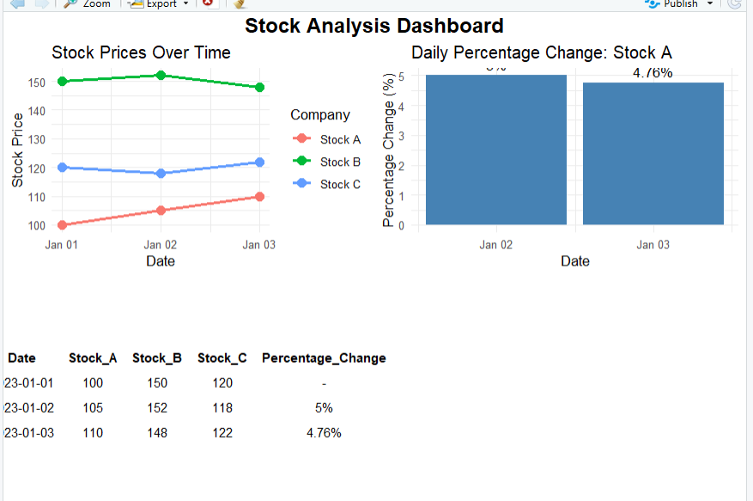
Result: The dashboard combines stock price trends, daily percentage changes for Stock A, and the stock price table for interactive exploration.

